LEGO:

The main goal of the Lego’s hardware team is to first knock down the bridge and push the umbrellas of the board. Then the robot will go across the bridge to the other team’s side, and get Botguy or the hydroponic garden. Next Botguy will be placed any where on our side of the board. Before time runs out the Lego robot will cross the bridge again and stay in place until the timer of two minutes goes off.
In order to balance the XPS they planned to add a third wheel on the back of the robot. However, they realized that it was not going to work because the third wheel would interfere with the other two wheels. Another way they redesigned this robot was by adding more support to the claw, so it would be stable because at the beginning when the robot tried to lift up Botguy the claw ended up falling.

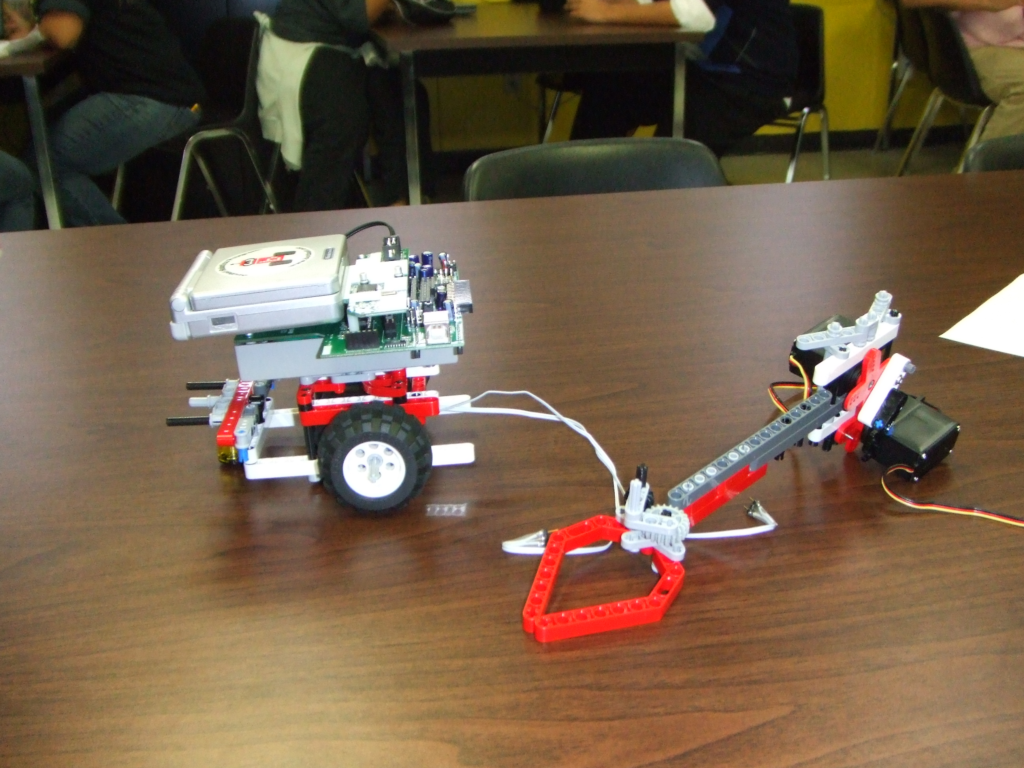

Create:

The main goal of the Create hardware team is to push the cups off the board, while at the same time placing the picking up as many balls as possible to place them in the shelter. Then they will go back and collect any balls left to put them in the solarium. At first the arm like-piece would grab the balls and when it was on the process of pushing it off the board the cup would stay attached to the robot and did not fall.
