Our robot will score 66 points in total. 45 points from the balls and 30 points for going onto the opponent’s safety zone, -9 points for the umbrella. We have deiced to do this only because it was the easiest way to make everything run smoothly and not have a problem at the last moment.

The iRobot will round up all of the balls and make sure that they will get to the safety zone fast and efficiently. When this is happening the other (small but powerful robot) will go the bridge and hit it down, it then will go on the other side and into their safety zone. The iRobot will then make its way to the cups and move then to the edge where they will just fall off the board!
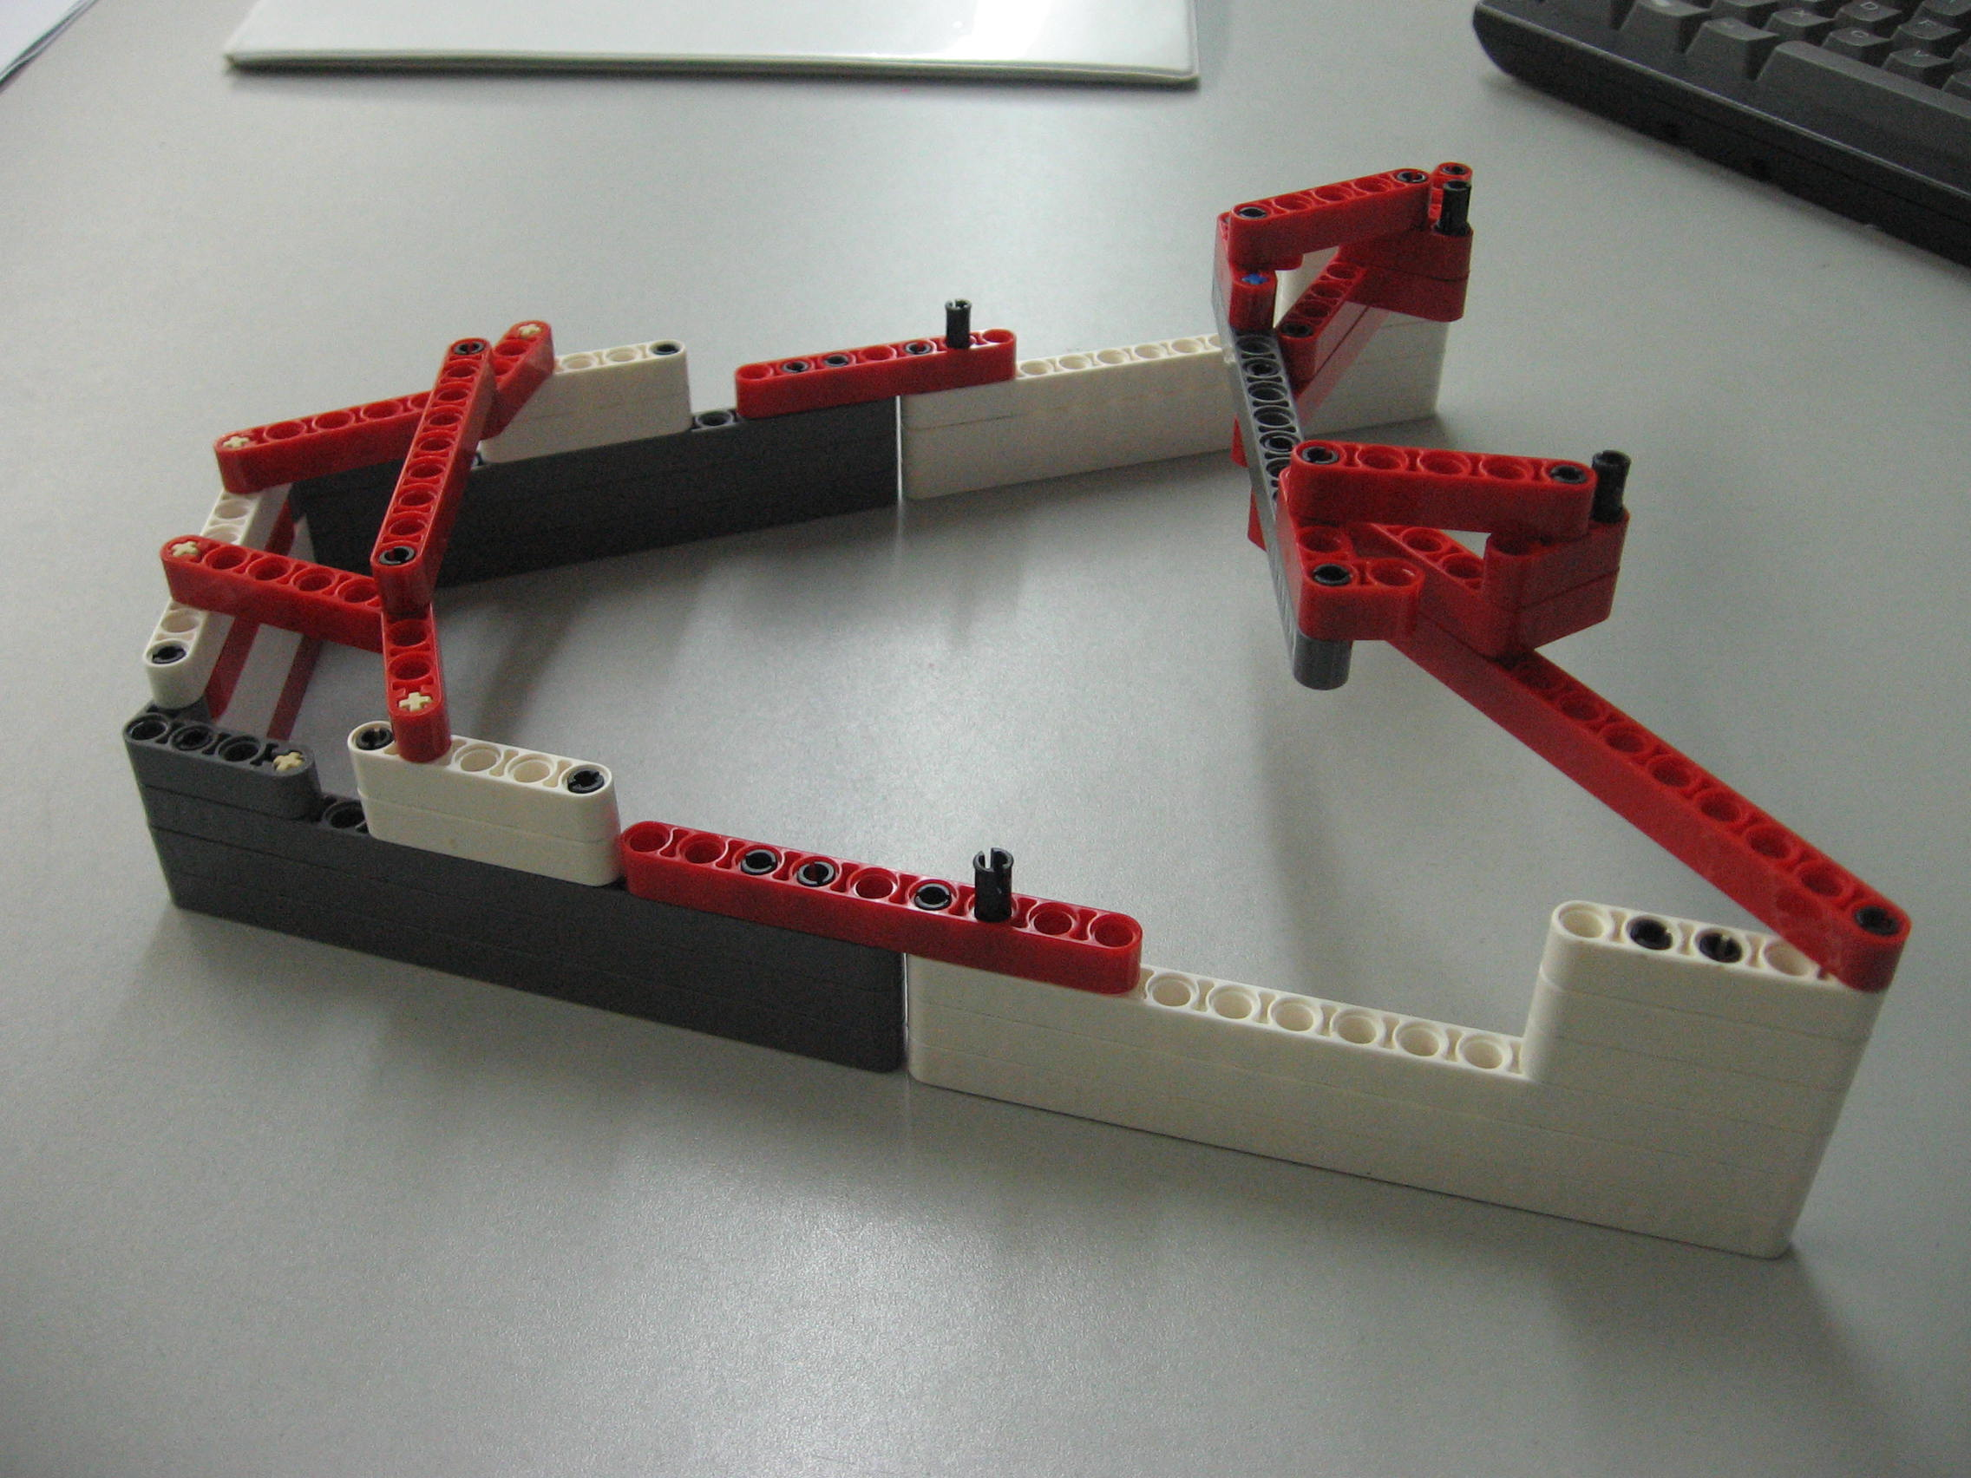
Balls
Cup
The most key feature that it will have is the claw. The balls will go into the open area where they will be keep until they are discarded into the safety zone on the board. The cups will fall off the board when they are hit by wall in the front This claw it very simple and efficient. Last year we had many complications with opening and closing a claw that wouldn’t cooperate. This year we have learned from our mistake and going after the smart “KISS” award.

The most difficult aspects of this concept would have to be The wall of the claw because sometimes the cup will get stuck on the bottom of it and hang on while the robot backs up to turn around. It this happens then we points will take off on our point. This would be one of the reasons that we take this design out off the concept!

