Robot one is still being worked on.
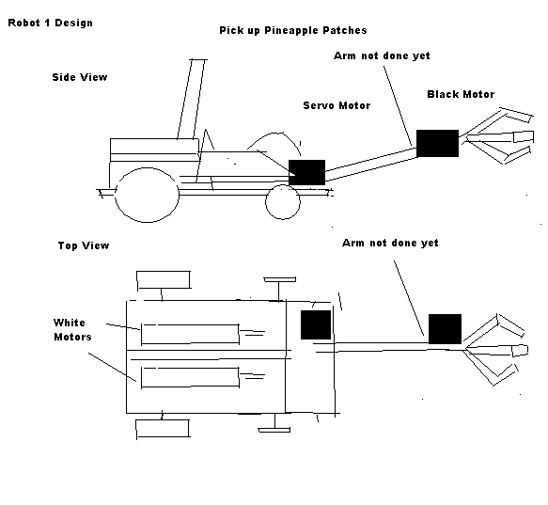

Robot two drops the hook inside the house using a servo motor and can drag it back to the home base. Dropping the umbrellas into the houses is still being worked on.
