Peninsula High School
March 7, 2007

Initial Design Concepts

1. The first concept we considered would focus on not just collecting our points but subtracting points from the other team as well. The robots would begin by collecting the poms and houses on our side. After collecting all the items the robots would sort the poms and put the water in the bins as well as put the umbrellas in the houses. Once the first forty five seconds pass, one robot would go and put up a wall to deflect all the lava poms on to the enemy side of the field with a expanding wall. Then the robots would go to the sides of the field where enemy robots could put lava or cross on to our field to protect it. The hardest aspect of this design would be making a wall that can deflect all the lava poms from our side.

2. Another concept we considered was attacking the other side with one robot. In the first fifty five seconds the robots would collect the poms, houses, and water. Then one robot would sort the poms into the correct bin while the other one moved the houses to the starting block and put the umbrellas in. Once the volcano erupts the robots collect all the lava on our side and move onto the enemy side to knock over their bins and houses and interfere wherever possible. The main features on these robots would be a claw for collecting the houses and waters. As well the other robot would have sweeper to collect poms. The hardest part of this design would be getting to the other side to interfere without flipping over.
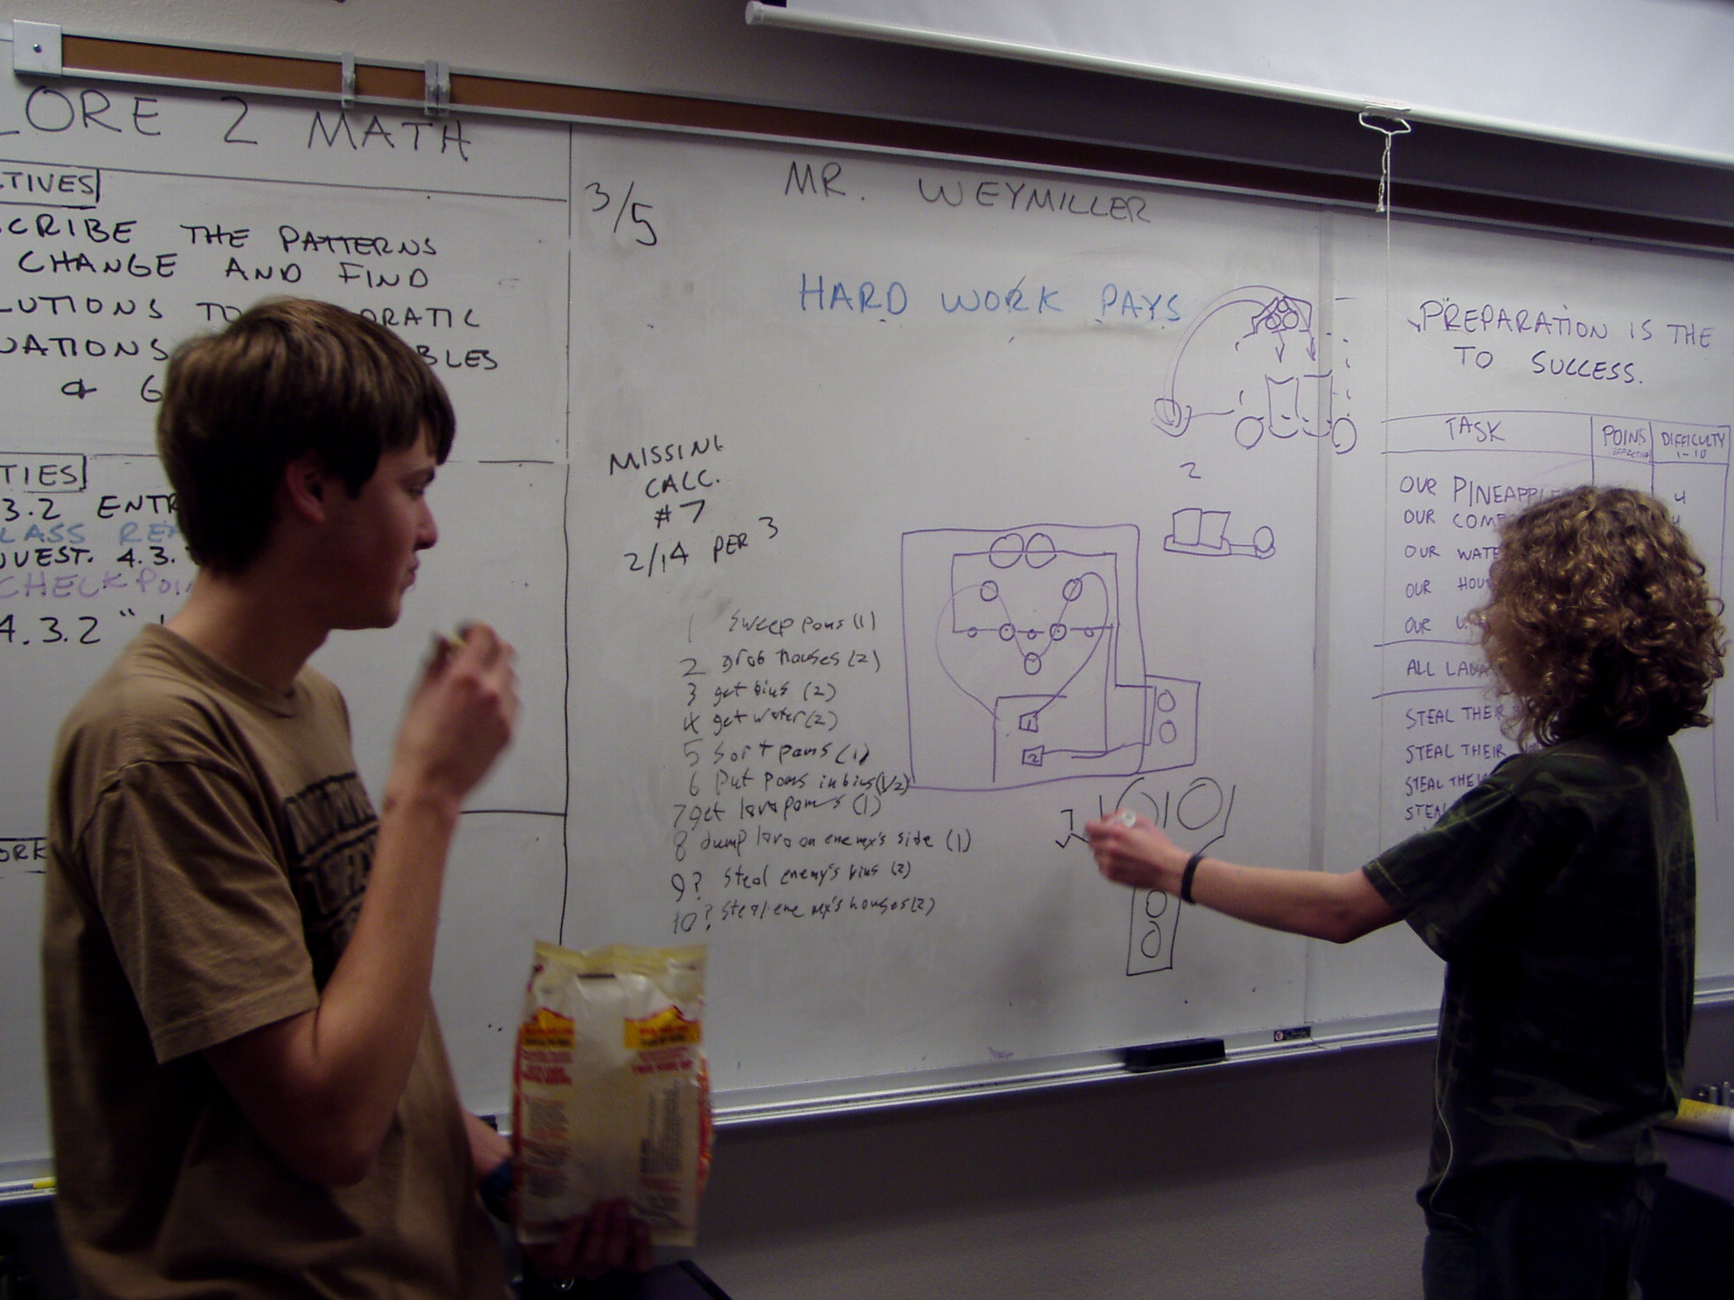

Planning the routes for the two robots, and assigning duties for each one.
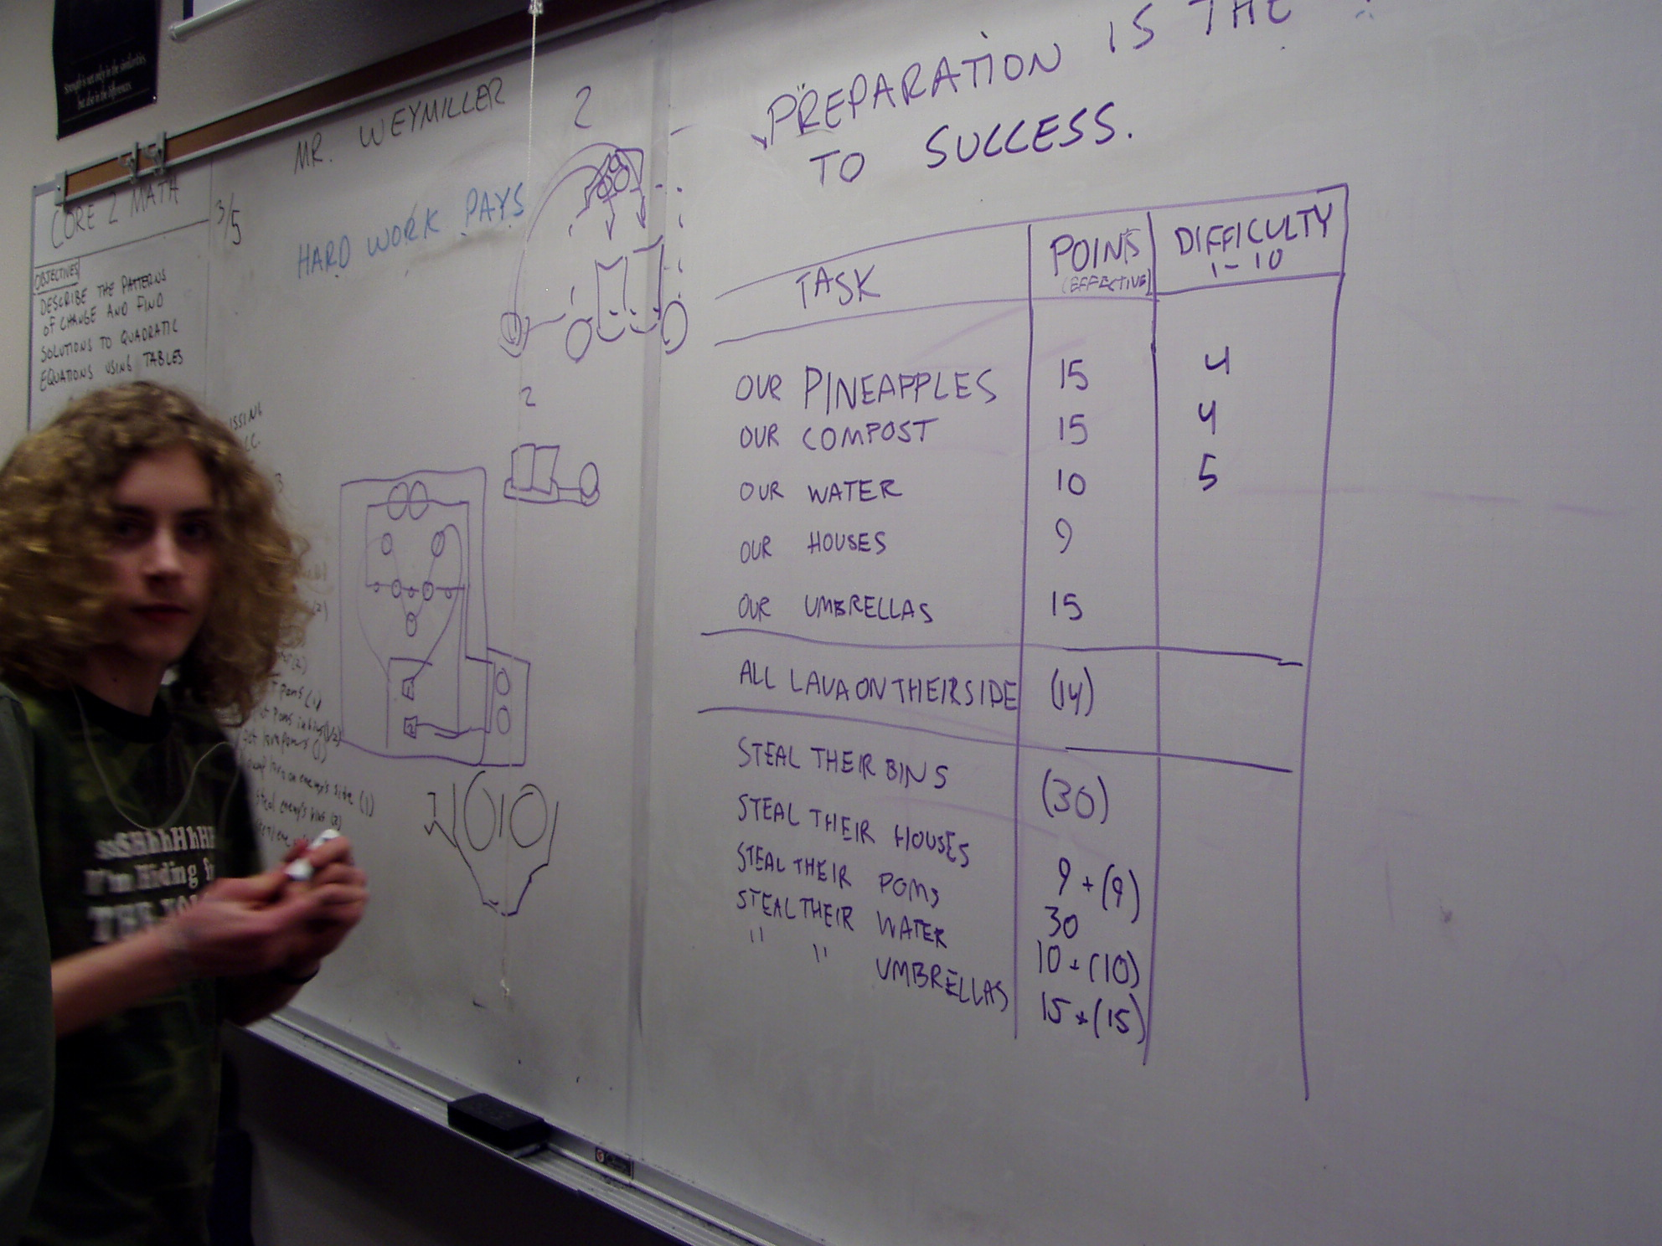

Task list, with details and difficulty ratings.

