Initial Design Concept 1: Tribble Bot and House Bot
Decision: Ideas Used for Final Design Concept
Tribble Bot:
Point Source : sorting pineapples and leaves
# of Points : 30
Key Features : Conveyor belt collector, Camera sorter
Difficulties : storing so many tribbles, sorting w/camera and needing it for navigation
House Bot:
Point Source : drop shield in each house, then return houses to home
# of Points : 24
Key Features : small shield dropping claws
Difficulties : Claws need precision

This design would use two robots: house bot, and Tribble bot. The house bot would travel to the houses to individually place a parasol in each one. The robot would make use of a rotational device with three prongs. Each prong would face as far away from the other two as possible, meaning each prong would be angled 120 degrees from the other prongs. This whole unit would be able to rotate horizontally, and when needed, tipped to the side. This would allow for a controlled release of the houses, giving the house bot more independence. Once all parasols would be deployed the house bot would return the houses to the home for addition points.
The Tribble bot would use two treads mounted vertically to raise pineapples and leafs onto the top of the robot. Once there, pineapples and leafs would be sorted into separate bins via a camera mounted on the top of the robot. Once complete, all pineapples and leafs would be sorted into their respective bins on the game board.
It was found that the house bot design would be mechanically too hard to build. Additionally, parasols would need to be dropped from a considerably large height for the bottom toothpick part to fit inside the houses. This would lead to inconsistencies when dropping the houses. The Tribble bot would unfortunately run into trouble with navigation because a camera would need to be constantly watching the treads as pineapples and leafs rise to the top. As a solution, the camera could be mounted on a rotational device, allowing it to change view. However, this also proved to be too hard to implement mechanically.
Initial Design Concept 2: Tribble Bot and House Bot
Decision: Ideas Used for Final Design Concept
Tribble Bot:
Point Source : Pineapples/Leaves sorted, deposited
# of Points : 30
Key Features : Either - Small Sweeping Claw, Comprehensive sorting technique, General storage space;
Or - 2 Small Sweeping Claws, 2 storage spaces
Difficulties : Precisely Grabbing and Depositing the leaves and pineapples, movement without the use of a camera
House Bot:
Point Source : 3 Houses in home, Waters placed on Bins
# of Points : 19
Key Features : Universal Claw, storage space, Pie (Greek letter) shape that allows house storage inside
Difficulties : Claws needing both the Strength to lift the waters and scoop up the houses
This concept design focused on creating a very skilled, well-programmed and mechanized robot (Tribble Bot) and a dumb bot, that would do relatively little thinking for a relatively sizable amount of points (House Bot).
The Tribble Bot would approach each pile with pineapples and leaves and pick them apart into its storage spaces by the designated mechanism (see diagrams) and sort them neatly so it can deposit both into the corresponding bins. It would then deposit them.
The House Bot would wait for the Tribble Bot to maneuver with the pineapple and leaf piles and then capture all the houses into its belly space and drive them into the home area. It would then use its claws to lift the waters from the 'ocean' and deposit them on top of the bins right after theTribble Bot is done.

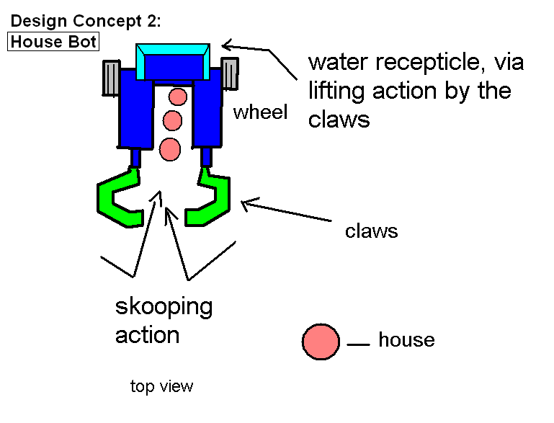
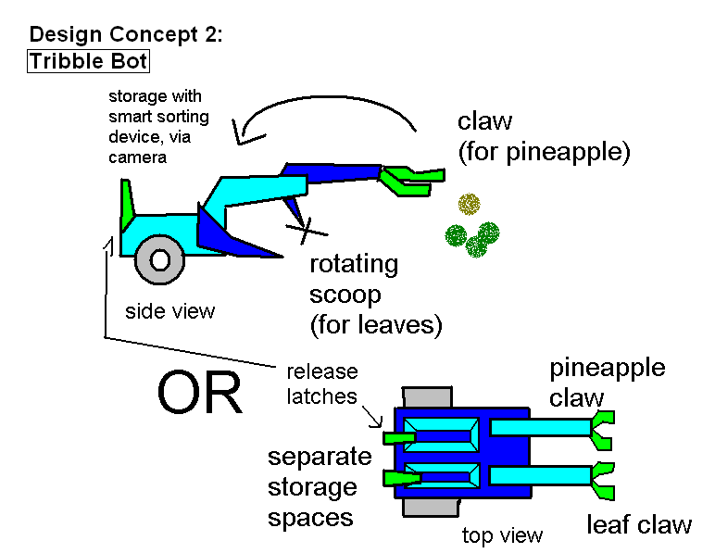
Initial Design Concept 3: Shield Bot and Water Bot
Decision: Ideas Used for Final Design Concept
Shield Bot: (2 versions)
Point Source : shielding houses
# of Points : 15
Key Features : pincers for umbrellas
Difficulties : Precisely Grabbing and Depositing the shields
Water Bot:
Point Source : 3 Houses in home and 2 water in bins
# of Points : 19
Key Features : small claws for picking
Difficulties : Claws need precision and strength/ top heavy
Another initial design that was formulated was one where one bot would score points by placing the umbrellas into the houses, and another bot, which places the water into the compost or pineapple bin, and then is responsible for plowing the houses into our starting bins. The Water Bot would use 4 small claws to grab the pineapples and balls. By the end of this strategy, we will score 15 points, 5 for each house, with the umbrella processing bot, and for the other bot, 5 for each water ball, and 3 for each pineapple for a total of 19 points. For a grand total, this strategy gains a max of 34 points out of a practical 64 points on our side.
In this strategy, the trees and the lava are ignored because they are so unpredictable in the places where they may end up. After the houses are given the umbrellas, the poms may be scattered everywhere, and the lava is inherently unpredictable. We save effort if we focus on the easier points.
The umbrella robot will have two conveyor belts that sandwich the 3 umbrellas, and then the bot will drive by the houses that are set up in a line and the drops off each umbrella into a house. Then that bot will park itself out of the way of the other bot. Then the water retrieving bot will go and grab each water ball with a claw and put it in the bin, and then will use a plow that is attached to the front of it to plow the houses that now have the umbrellas into the starting box.
The most difficult aspects of this strategy include the creation of a claw that won’t make the bot too top heavy, and the timing of the disposals of the umbrellas into the bins.
Initial Design Concept 4: MLMR (Mini Lava Management Robot)
Decision: Ideas Used for Final Design Concept

Point Source : Lava
# of Points : 14 point net gain
Key features : lava collection with conveyor belts, lava propulsion with motor and wheel. Compact design, minimal piece usage
Issues: Inefficient use of one XBC

This robot was a preliminary design that did not carry on to a further time due to the inefficiency of the robot.
The basic idea was to create a small, compact robot that would take up little space and would dispose of any lava on our side. The robot would use conveyor belts to move the lava to a lava shooting mechanism, and would propel the lava onto the opponent’s side, causing confusion.
This robot would give us a net gain of 14 points, getting rid of the -7 on our side, and adding -7 to the opponent’s side. Rejection of the design stemmed from the group’s decision that 14 points was not enough and an inefficient use of an XBC controller.
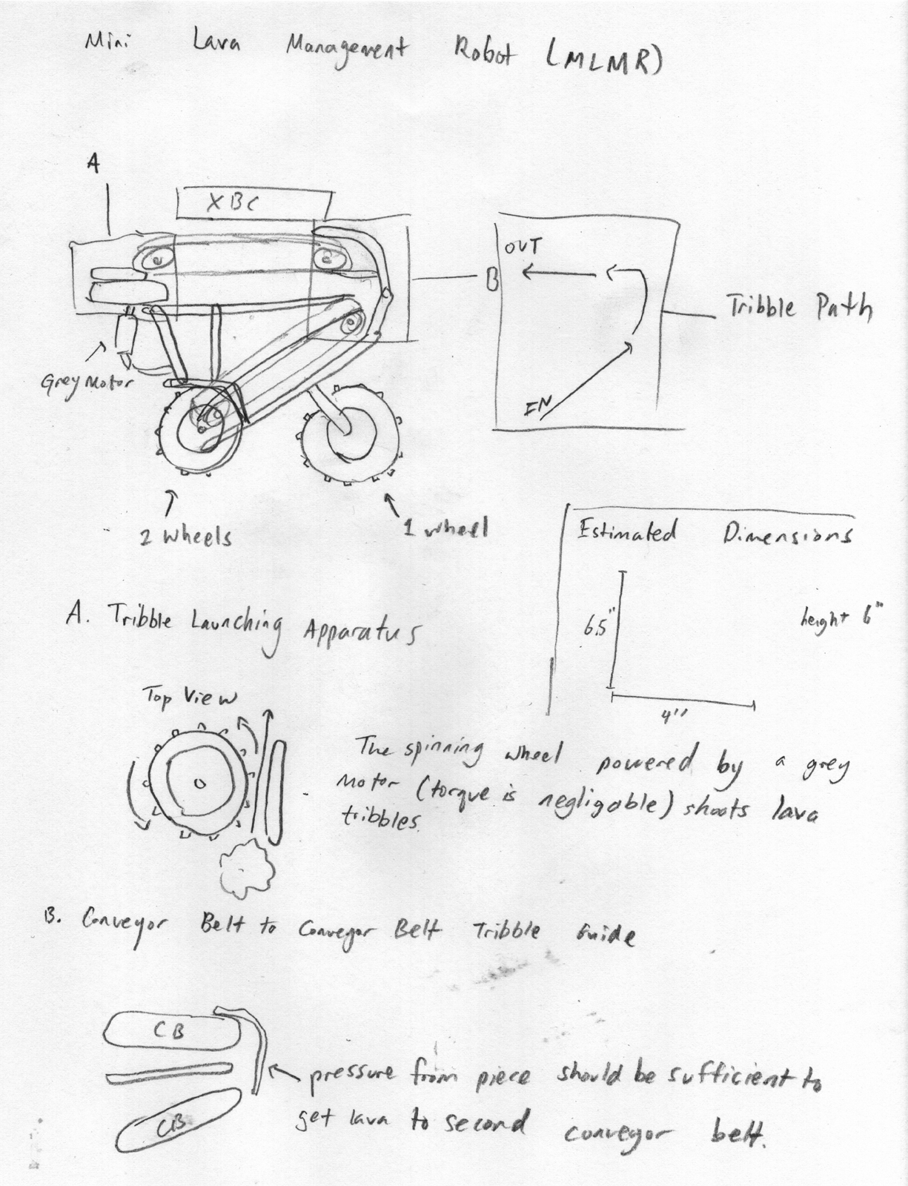
Initial Design Concept 5: Tribble Bot and House Bot
Decision: Accepted

Tribble Bot:
Point Source : Unsorted pineapples/leaves dumped, water
# of Points : 25
Key Features : Giant Sweeping Claw, Garbage Truck Dump Bucket
Difficulties : Mechanical Creation, Task Completion in Time Frame

House Bot:
Point Source : 3 Houses in home w/ shields
# of Points : 24
Key Features : Underbelly Storage, Shield Placing Arm
Difficulties : Board Maneuvering

In this initial design there are two robots, each with specific functions. Tribble Bot’s goal is to collect the pineapple trees (three green leaves and one yellow pineapple) and dump them unsorted. In addition Tribble Bot will grab and place a blue water ball in each bin. Tribble Bot first collects three trees. Upon collection of the three trees it will dump them in the green leaf bin. This will obtain 9 points. Tribble Bot will then collect the remaining two pineapple trees and dump them into the yellow pineapple bin. This collecting of trees is done through a giant sweeping claw and a dump truck style bucket on the back of the robot. Once done dumping all trees, the robot will search for the blue water balls and then grab one and store it in its back bucket. Immediately after storing the 1st water the bot will grab the 2nd water in its claw and proceed to placing one water in each bin. This is the end of Tribble Bots task line and by the end of the time limit, it should have obtained roughly 25 points total. The difficult aspects of implementing Tribble Bot will be the building of the claw and bucket in addition to small timeframe this bot has to do so many tasks. Both the claw and the bucket are intricate in design and may take a while to build efficiently. However, most building tasks can be overcome with enough time and thinking. Unfortunately overcoming the time limit may not be so easy. It will probably take at least 40 seconds to pick and dump the first three trees. It may take another 25 seconds to do the last two trees and 25 seconds to do the water balls. This is a very tight schedule for the bot. It will be difficult to determine a path and the programming for this bot to cut down the estimated time the bots goals take to complete. The other robot, House Bot, is much simpler in design and in theory may have a quicker more reliable way to obtain points. House Bot’s goal is to collect the three houses and then put a shield in each. To do this, House Bot basically drives over the houses and stores them in its belly. Once it eats all three houses, it will return to the home. Here, the bot will back up and drop and arm holding the shields into the houses. This bot will garner 24 points. Because all this robot only has to drive and avoid disturbing the playing field for Tribble Bot, there are only a few minor challenges. One possible problem is how to steer the robot around the board. We have decided to use the camera to locate board landmarks and then use these to guide the robot.
After reviewing all our design concepts, the team decided that this concept best met our goals for the competition. The robots described in this plan are relatively simple to build and will bring in high, consistent scores. In addition the robot designs and strategies are point efficient and practical.

