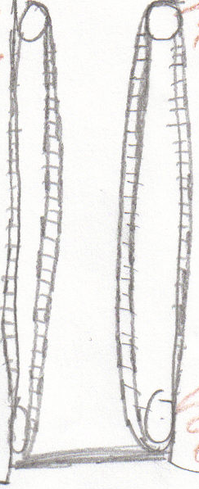
v
Prongs
Semi-rotating motor
(Controls tripper blade to trip the cups, which rotates in a counter-clockwise rotation)
Cup-stopping bar

Cup-hooking device

Tires

Treads
Three (3) cup lengths
Three (3) cup lengths

Walls about the height of a cup

Location for RCX of the “brain”
Date: January 25, 2004

